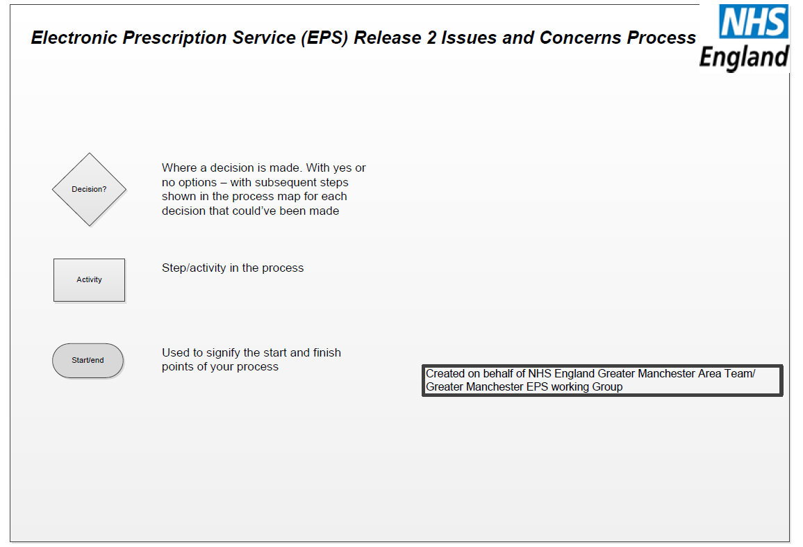

**Electronic Prescription Service (EPS) R2 Issues Process**

The Greater Manchester Area Team (GMAT) has produced the following guidance in collaboration with GM EPS working group and Community Pharmacy Greater Manchester (CPGM); this is to enable contractors to understand the process in dealing with patient and ‘contractor to contractor’ concerns/issues.

NHS England’s national guidance for nominations was issued in June 2013, this can be accessed www.hscic.gov.uk/eps (‘Nominations: What you need to know’). Based on this, the GMAT has implemented a local process for obtaining patient written consent and a suggested template (refer to Appendix 2) is available by request to the team at [AGM.optometry-pharmacy@nhs.net](mailto:AGM.optometry-pharmacy@nhs.net) .

GMAT advises contractors as good practice, to capture patient written consent by using the agreed local template. This can be utilised for audit purposes and in ensuring contractors are clearly ‘explaining to patients what nomination means’.Contractors need to advise patients if their GP Practice has yet to go live with EPS R2 and that the service they are consenting to is unavailable at present.

**EPS R2 IM01 Delayed Prescriptions**

If an electronic prescription is not available at the pharmacy as expected the pharmacy should first check that they are the nominated pharmacy or gain agreement from the patient to proceed. The EPS Prescription Tracker enables the contractor to undertake a search using the patients NHS number or alternatively call the GP practice for the prescription ID to manually retrieve the prescription. If the prescription is still not available then this should be reported to the contractors dispensing system supplier. The numbers in the following processes relate to the steps in the following flowcharts (refer EPS-IM01).

***The process for the delayed prescriptions is as follows:***

1. The electronic prescription is not available in the pharmacy as a result of a failure to download the nominated prescriptions.
2. The pharmacy contractor needs to follow their dispensing system user guide to check the patient’s nomination.
3. If you are **not** the nominated pharmacy discuss this with the patient.
4. Advise the patient of their nominated pharmacy and ask patient if they wish to use their nominated pharmacy.
5. Where the patient wishes to use their nominated pharmacy direct patient accordingly.
6. Where patient does not wish to use their nominated pharmacy and you have their agreement, telephone the nominated pharmacy to request the barcode number and ask them to return the prescription back to the spine.
7. Use the barcode number supplied to download the prescription from the spine and dispense as per your standard operating procedures.
8. Where **you are** the nominated pharmacy, can you access the prescription tracker via the link <https://portal2.national.ncrs.nhs.uk/prescriptionsadmin/> ?

***(If yes, go to step 14)***

1. If you **cannot access the prescription tracker** contact your pharmacy system supplier to allow access to the site before alternatively contacting the relevant GP Practice. ***(NB: If access given, go to step 14).***
2. If you have to contact the GP Practice - ask the GP practice to check that the prescription has been authorised? ***(If yes, then go to step 13)***
3. If no, ask the GP Practice to process and authorise the prescription **(NB: it could be awaiting a GP signature).**
4. Can the prescription be downloaded from the spine? ***(If yes, then go to step 18)***
5. Where the prescription has been processed by the GP practice and cannot be pulled down from the spine. The GP Practice will need to provide prescription ID/bar code number or a prescribing token were practical ***(then go to step 15).***
6. If you **can access the prescription tracker *via the link**, search the system by the patients NHS number and date range, to obtain the prescription ID/bar code number.
7. Manually type in the prescription ID/bar code number to retrieve the prescription.
8. Can the prescription be obtained?
9. If no, contact your pharmacy system supplier. If the issue has not been resolved then request they escalate this to the national HSCIC helpdesk and ensure a national incident number is obtained, for further action.
10. If yes, then process the prescription and the matter is closed.

**EPS R2 IM02 Nomination issue/concern**

If the patient wishes to make a complaint, they should make that complaint with the relevant contractor i.e. pharmacy, dispensing appliance contractor or GP Practice in the usual way. If the patient feels that the issue cannot be resolved and/or wishes to raise the complaint with NHS England these should be directed either by telephone 0300 311 2233 or by email at [england.contactus@nhs.net](mailto:england.contactus@nhs.net) .

If a contractor wishes to make a complaint about another contractor, the GMAT have implemented a method to ensure issues/concerns are handled appropriately. The flowchart is split into two pathways, one for patient concerns and one for contractor concerns. The numbers in the following processes relate to the steps in the following flowcharts (refer to EPS-IM02).

***The process for the patient concerns are as follows:***

1. Patient has raised a concern regarding their nomination.
2. The patient should in the first instance raise this concern with the relevant contractor
3. The patient and contractor should discuss together to try to resolve the issue. The contractor needs to ensure they have documented the concern (as per their internal procedures).
4. The patient if they wish can make a formal complaint if they feel the matter has not been resolved satisfactory.
5. If they decide against making a formal complaint the matter is closed.
6. If they decide to make a formal complaint the patient should be advised to contact NHS England either by telephone/email/writing.
7. NHS England will investigate the issue on behalf of the patient.
8. NHS England will communicate and action as required.

***The process for the contractor concerns are as follows:***

1. A contractor has a concern regarding nominations.
2. The relevant contractors involved should look to resolve the concern/issue amicably together and resolve locally.
3. If the matter is resolved with a successful outcome then it is closed. If the matter has not been resolved, then the contractor will need to seek support from the Local Pharmaceutical Committee (LPC).
4. The matter is closed.
5. The contractor will need to contact their LPC as per contact details (refer to Appendix 1).
6. The LPC will look into the matter and facilitate discussion if appropriate.
7. The matter will be reviewed in collaboration with the LPC and contractors.
8. If the matter is resolved with a successful outcome then it is closed. If the matter has not been resolved, then the contractor will need to keep a record log and gather evidence.
9. The matter is closed.
10. The contractor has sufficient and comprehensive evidence relating to the issue/concern highlighted. The contractor needs to escalate the matter with supporting evidence, in writing to the GMAT via the teams generic email address [AGM.optometry-pharmacy@nhs.net](mailto:AGM.optometry-pharmacy@nhs.net) (as per flowchart step 14).
11. If the contractor does not have required evidence. The contractor needs to gather the required evidence and monitor as required.
12. If the evidence has been obtained, the contractor needs to escalate the matter with supporting evidence, in writing to the GMAT via the teams generic email address [AGM.optometry-pharmacy@nhs.net](mailto:AGM.optometry-pharmacy@nhs.net) (as per flowchart step 14). If no evidence available then the matter cannot be escalated to be investigated.
13. If no evidence obtained the matter is closed.
14. Escalate in writing, to the GMAT by email.

***Acknowledgements:***

Suzanne Russell

Alison Flannery

Sharon Austin

***Prepared by***: Pina Renzulli/Vonda Hamilton

***Date prepared***: December 2014

(Version 2)

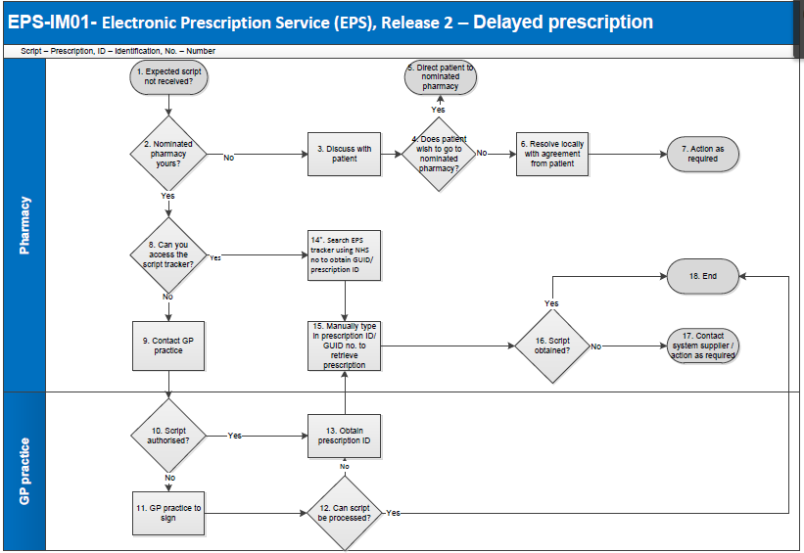

***\*To access the prescription tracker using your PC and smartcard. Click or paste the following link into your web browser:*** [***https://portal2.national.ncrs.nhs.uk/prescriptionsadmin/***](https://portal2.national.ncrs.nhs.uk/prescriptionsadmin/)

***Any issues accessing the EPS prescription tracker contact your IT system supplier.***

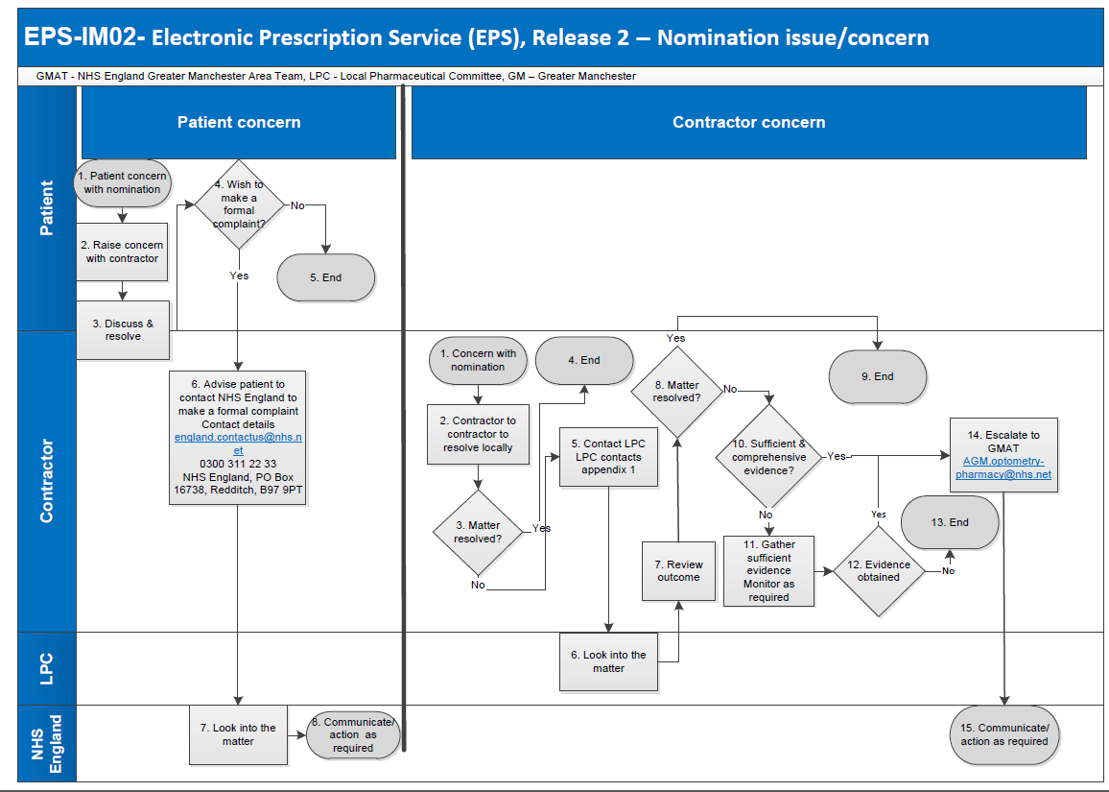

**Appendix 1**

**Greater Manchester Local Pharmaceutical Committee (LPC) Contact List**

|  |  |  |  |  |
| --- | --- | --- | --- | --- |
| **LPC** | **Main Contact/Role** | **Email Address** | **Phone No** | **Address** |
| Community Pharmacy Greater Manchester (CPGM) | Helen Reed/Nicole Lee Administration Assistant | [enquiries@cpgm.org.uk](mailto:enquiries@cpgm.org.uk) |  | Suite 10 Barlow House,  Minshull Street,  Manchester  M1 3DZ |
| Ashton, Leigh & Wigan | Bruce Prentice -Secretary | [bp@brucie.co.uk](mailto:bp@brucie.co.uk) | 077144 24343 | 149, Milner Road, Heswall,  Wirral, CH60 5RY |
| Bolton | Louise Gatley/Secretary | [louisegatley@btinternet.com](mailto:louisegatley@btinternet.com) | ***Tel:*** 01204 840366  ***Mob:*** 07515 285178 | 26 Camellia Close, Heaton,  Bolton, BL1 4NY |
| Bury AND Heywood, Middleton & Rochdale | Ian Short/Chief Officer | [GMHUB.BROTGLPC@nhs.net](mailto:GMHUB.BROTGLPC@nhs.net) | ***Tel:*** 01706 751585  ***Mob:*** 07734 259460 | Office 14, Evans Business Park Centre, Dane Street, Rochdale, OL12 6XB |
| Oldham AND Tameside & Glossop | Ian Short/Chief Officer | [GMHUB.BROTGLPC@nhs.net](mailto:GMHUB.BROTGLPC@nhs.net) | ***Tel:*** 01706 751585  ***Mob:*** 07734 259460 | Office 14, Evans Business Park Centre, Dane Street, Rochdale, OL12 6XB |
| Manchester | Claire Dickens/Secretary | [claire@cpgm.org.uk](mailto:claire@cpgm.org.uk) | 07841 830706 | Suite 10 Barlow House,  Minshull Street,  Manchester  M1 3DZ |
| Salford AND Trafford | Bethan Pickup/Secretary | [saltraflpc@gmail.com](mailto:saltraflpc@gmail.com) | 0161 661 5446 | 29, Beatrice Road, Worsley,  Manchester, M28 2TW |
| Stockport | Gillian Stone /Secretary | gillian.stone@pharmacy.co.uk | 07801 100216 | c/o 17 Highfield Close, Davenport, Stockport, SK3 8UB |

**Appendix 2**

|  |  |  |
| --- | --- | --- |
| **Electronic Prescription Service**  **Patient Nomination Consent Request** | | |
| **Patient Name:**………………………………………… | **DOB:** …………………….......... | |
| **NHS Number:** ……………………............................. | | |
| **Address:** ................................................................... | |  |
| .................................................................................... | | **Telephone Number:**............................... |
| **Post Code:** ................................................................ | |  |
| ***Nomination has been explained to me by staff at my GP practice / community pharmacy / appliance contractor and I have also been shown the patient information leaflet that explains nomination.***  I have read the leaflet ‘Patient information Sheet’ (published by ***\****HSCIC) – explaining the Electronic Prescription Service nominations information for patients/careers, and understand what I have to do.  I confirm that patient nomination has been explained to me and I understand what I am consenting to.  I confirm that I have made my nomination of my own free will and have not been influenced or given a gift to select a particular nomination and that I can change my mind at a later date.  ***\*(available via www.hscic.gov.uk/epspatients)*** | | |
| **Name & Address of nominated dispenser (*please print*):** | | |
| **Please cross out where appropriate:**  ***I am the patient named above / carer of the patient named above.***  **Patient/Carer Name:**……………………………………………………………………………………  **Signature:**………………………………………………………………………………………………..  **Address (only if different from above):**  .......................................................................................................................................................  .......................................................................................................................................................  **Date:**………………………………………………………………….……………………………………  **Staff Name:** ………………….…………….……………………………………………….…………….  **Staff Signature:** ………………………………………………………………………………………….. | | |