

**Electronic Repeat**

**Dispensing**

**Project**

**Handbook**

**Flow charts and quick reference guides for**

**General Practice Team**

Adapted from the North Manchester CCG/GMLPC Electronic Repeat Dispensing Project

**Contents**

|  |  |
| --- | --- |
| Headings | Page No. |
| Introduction | **3** |
| What is eRD? | **4** |
| How does it work? | **5** |
| Training and Information | **8** |
| Manchester eRD Project? | **9** |
| Consent | **11** |
| eRD Champions / Leads | **12** |
| eRD Eligibility Criteria | **13** |
| eRD Exclusion Criteria | **13** |
| Additional Requirements of the eRD Service | **14** |
| Figures: |  |
| Figure 2: Adding a Patient to the eRD Service | **16** |
| Figure 3: Cancelling or part cancelling an eRD Prescription | **17** |
| Figure 4: Adding or amending a drug in the middle of a current cycle | **18** |
| Making an amendment to a current eRD | **19** |
| EPS Tracker | **19** |
| FAQ’s | **20** |
| Appendices: |  |
| Appendix 1: Nomination Form (inc. Written consent) | **22** |
| Appendix 2: List of Suitable Patients (for GP approval) | **23** |
| Appendix 3: Referral Form (Pharmacy Use Only) | **24** |
| Appendix 4: Complaints Procedure and Incident Reporting | **25** |
| Appendix 5: Electronic Prescription Service (EPS) - Prescription Tracker  Factsheet | **26** |
|  |  |

**Introduction**

Two thirds of prescriptions issued in primary care are repeat prescriptions. These repeat prescriptions account for nearly 80 per cent of NHS medicine costs for primary care. The management of these prescriptions and the time involved in processing them can be significant.

In order to provide a more efficient way to manage repeat prescriptions in 2005 the government introduced the Repeat Dispensing service (RD). Since July 2009 it has been possible to use repeat dispensing via Release 2 of the Electronic Prescription Service (EPS), also known as Electronic Repeat Dispensing (eRD).

Despite the benefits of eRD, the uptake of the service has been low. Manchester Clinical Commissioning Group (CCG) can see the potential of the eRD service and in collaboration with Greater Manchester Local Pharmaceutical Committee (GM LPC) are working to deliver an eRD project across Manchester.

The project proposes to support the wider health system through better use of the community pharmacy network, with the aim to significantly increase the use of the service by patients.

**What is eRD?**

According to an NHS repost, there are up to 410 million repeat prescriptions generated every year equivalent to an average of more than 200 per GP per week. It is estimated that up to 330 million, or 80 per cent, of all repeat prescriptions could eventually be replaced with repeat dispensing; this could save 2.7 million hours of GP and practice time.

Originally this service was carried out using paper prescriptions, but as the Electronic Prescription Service (EPS) has developed, the majority of repeat dispensing is now carried out via EPS release 2 and is termed Electronic Repeat Dispensing (eRD). eRD is more efficient and convenient for all involved.

Some benefits of Electronic Repeat Dispensing (eRD) include:

• Saves GP practice time and expense – less transactions related to repeat prescribing thus a reduction in demand of GP time.

• Reduces long term workload for both GPs and clerical staff in processing repeats and dealing with related queries, allowing them to schedule their workload more efficiently.

• eRD prescriptions can be amended or cancelled at any time by the GP as with a standard repeat prescribing system.

• Saves patients time by not having to order repeat prescriptions at regular intervals and added convenience of just collecting prescriptions from their pharmacy

• Improves patient care, by reducing the risk of any delays in patients receiving their medication.

• Potential reduction in prescribing costs and waste reduction.

• An auditable system as prescriptions are visible on the NHS tracker.

eRD allows the prescriber to authorise and issue a batch of repeat prescriptions electronically for up to 12 months with just one digital signature. Once the service is set up, the patient’s nominated dispenser receives the issues at the intervals specified by the prescriber until the patient needs to be reviewed.

.

**How does eRD work?**

Figure 1 outlines the eRD process.

**Multiple Issues**

The GP reviews the patient’s medication and comorbidities. If deemed suitable for eRD, a batch of repeatable prescriptions is issued electronically. The number of issues within the batch, and the interval between each repeatable issue is determined by the prescriber.

**Issues are retrieved one-by-one**

The first repeatable issue is available immediately as soon as the prescription is received by the Spine, which then manages the release of each subsequent repeatable prescription issue at the specified interval.

The first repeatable issue is dispensed by the pharmacy and supplied to the patient. The pharmacy is able to send a claim notification to the spine for payment.

**Automated process for allowing time to prepare medicine for each issue**

To allow pharmacists to prepare medicines for dispensing in advance of a patient visiting the pharmacy or the requested delivery date, the Spine will automatically send subsequent repeat issues, to the nominated dispensing site seven days before the expected end date of the previous issue of the prescription.

Items owed on a previous prescription still outstanding, for example, may prevent the successful download of a subsequent issue of an eRD prescription. This may vary depending on the dispensing software used in community pharmacies. Please refer to the user manuals of your dispensing software with respect to downloading and processing eRD prescriptions.

**Ensure that each repeat supply is required**

Prior to each dispensing episode the pharmacist will ensure that the patient is taking or using, the medicines or appliances appropriately. The pharmacist will ensure which items are required for this particular episode. The pharmacist must ensure that the patient is not suffering any side effects from the treatment which may suggest the need for a review of treatment.

**A new repeatable prescription requested for after the last issue**

Once all repeatable issues of the batch have been dispensed, or if the prescription has expired, the repeatable prescription batch is complete and the patient must contact their GP to arrange for another batch of repeatable prescriptions to be issued. Pharmacists should advise patients of the need to contact their prescriber when dispensing the last issue of a repeatable prescription.

This can be an ideal opportunity to get the patient to come in for a review before issuing the next batch of repeat prescriptions.

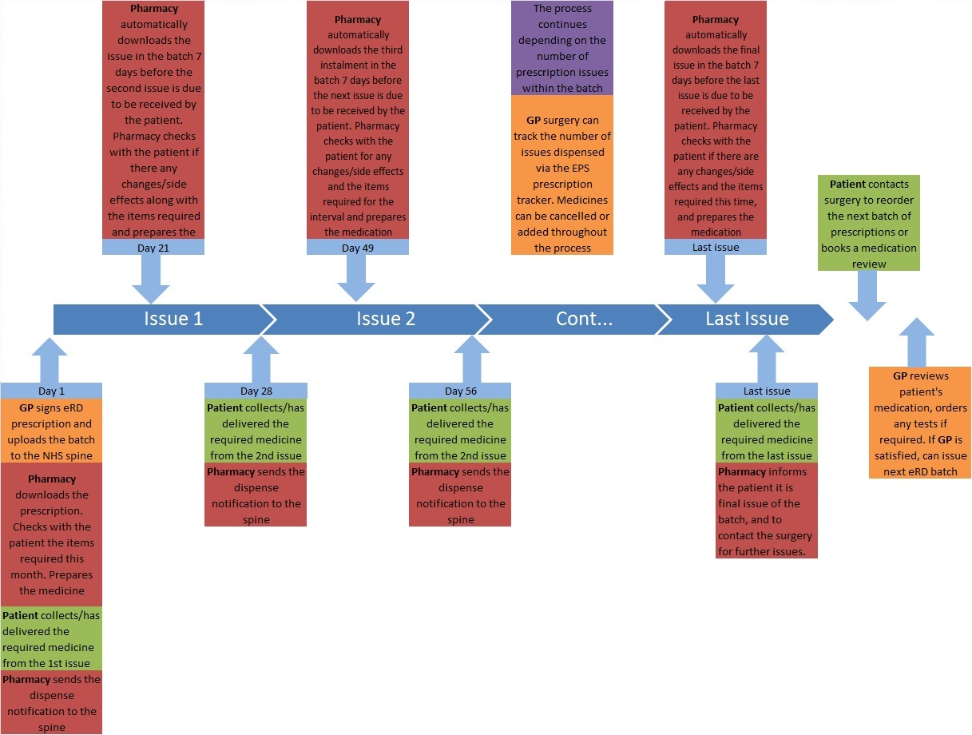**Training and Information**

Figure 1: Outline of the electronic repeat dispensing process

There has been relatively low uptake of the service across Manchester and the country as a whole. One of the reasons cited for this is due to lack of GP engagement with the service. Therefore the NHS has put together some training materials as they do acknowledge this is a different way of working and prescribers and their supporting admin team will not be familiar with eRD and its benefits.

* **NHS England Electronic Repeat Dispensing Guidance:**

[**https://www.england.nhs.uk/digitaltechnology/wp-content/uploads/sites/31/2015/06/electronic-repeat-dispensing-guidance.pdf**](https://www.england.nhs.uk/digitaltechnology/wp-content/uploads/sites/31/2015/06/electronic-repeat-dispensing-guidance.pdf)

* **Electronic Repeat Dispensing for prescribers training module:**

[**https://learning.necsu.nhs.uk/nhs-digital-electronic-repeat-dispensing-elearning/**](https://learning.necsu.nhs.uk/nhs-digital-electronic-repeat-dispensing-elearning/)

* **Electronic Repeat Dispensing for prescribers:**

[**https://digital.nhs.uk/Electronic-Prescription-Service/Electronic-repeat-dispensing-for-prescribers**](https://digital.nhs.uk/Electronic-Prescription-Service/Electronic-repeat-dispensing-for-prescribers)

* **eRD on demand webinar**

[**https://digitising-medicines.online-event.co/registration/nhs-digital-4**](https://digitising-medicines.online-event.co/registration/nhs-digital-4)

**Manchester eRD project**

In brief, this is what the Manchester eRD Project is proposing:

• Each pharmacy has to identify a minimum of twenty patients who may be suitable for the eRD service over a four week period.

• The pharmacy will be required to discuss with each of the identified patients the benefits of the service.

• The pharmacy will obtain written consent for the eRD service. (Appendix 1)

• The pharmacy will submit a list of the patients identified as suitable for eRD service along with the patient consent forms, to the respective GP surgery. (Appendix 2)

• The pharmacy is advised to send a list of patients each week to the GP surgery rather than waiting for the end of the four week period. This is to give GPs sufficient time to review the patients.

• The GP will review the patient and commence the eRD service if deemed suitable and in the patient’s best interest.

• Patients will be issued a number of repeatable prescriptions determined by the GP practice. (Please note this can differ from practice to practice).

• The pharmacy will dispense the repeat prescription issues within the batch.

• Prior to each dispensing episode the pharmacist will ensure the patient is using the medication or appliance appropriately, and the patient is not suffering any side effects.

They should ask the following questions:

* Have you seen any Health Professional (GP, Nurse or Hospital Doctor) since your last repeat was supplied?
* Have you recently started taking any new medicines either on prescription or that you have bought over the counter?
* Have you been having any problems with your medication or experiencing any side effects?
* Are there any items on your repeat prescription that you do not need this month?

The pharmacist can then use their judgment to determine if the patient needs to be referred back to their GP for a further review of their treatment. If patient needs to be referred please use the form in Appendix 3 to communicate with the prescriber.

• The pharmacy will fulfil the requirements of the service specification of the repeat dispensing service (please see training and education section in the booklet),

• Follow any relevant in house SOPs related to the Repeat Dispensing service.

• When supplying medication to the patient from the last repeatable issue within the batch, the pharmacy will inform the patient of this being the final remaining issue of their repeat medication,

• The pharmacy will advise the patient to contact their GP surgery for the next batch of prescriptions for the service to continue.

* Questionnaires will be sent out to gather feedback from patients, GP practices and community pharmacies involved in the project.

**Consent**

NHS Repeat Dispensing service requires the patient or their carer to consent to the introduction of two-way sharing of their information between the pharmacy and the GP practice. Written consent is not required; however it is good practice for a record of any agreement and the consent to be included in the patient’s notes or management plan.

For this project, written consent **must** be obtained by the community pharmacy in the form provided (Appendix 1), and a copy of the consent form will be shared with the GP practice.

**eRD Champions / Leads**

It is recommended each practice nominates an eRD champion, who would be responsible for the following:

* Act as the local expert on eRD
* Advise colleagues on current eRD levels
* Highlight areas where eRD could be used better
* Monitor the use of eRD locally and keep a log of any issues that arise
* Act as a contact point for colleagues who have any queries
* Promote eRD at patient liaison groups
* Ensure patient information for eRD is well positioned and used within the GP practice
* Liaise with community pharmacy colleagues
* Provide training to other colleagues as needed

**eRD Eligibility Criteria**

A patient deemed to be suitable for eRD service will have to fulfil the following:

1. **Patients with long term conditions**

Patients receive medication regularly to treat their long term conditions such as hypertension and diabetes.

1. **Stable Medication Therapy**

No significant changes in the last 6 months and no anticipated changes for the duration of the suggested batch

1. **Stable condition**

No recent unplanned hospital admissions (in the previous 6 months)

Patients suitable for eRD service can be identified using the patient medication records, when conducting medicine use reviews (MUR), or the new medicine service (NMS).

**Monitored Dosage Systems (MDS)**

Patients using MDS can be suitable for eRD as long as the patient or their carer(s) consent to the service, fulfil the criteria stated above and have no excluding parameters (see below).

**Exclusion criteria**

The patient is not suitable for the eRD service if they are included in the following patient groups:

• Take **any** schedule 2 or schedule 3 controlled drugs (including Midazolam)

• Take **any** benzodiazepines (e.g. Diazepam)

• Take any specials/unlicensed medicines on a regular basis

• Take any medication which requires frequent monitoring (e.g. Warfarin, Methotrexate)

• Suffering from any terminal illness

**Additional Requirements of eRD**

The following are important points to note when adding a patient to the eRD service.

**A Nominated Pharmacy**

To be able to use the eRD service the patient will have to nominate a pharmacy. Patients can change their nominated pharmacy at any time during the eRD cycle.

**DM+D items**

All the items on an electronic repeat dispensing prescription must be in the dictionary of medicines and devices (dm+d) to be suitable for electronic prescribing. This is the same as a normal EPS Release 2 prescription.

**PDS**

For any prescriptions to be sent electronically the PDS icon must **NOT** be red. Please take sufficient steps to ensure this is rectified before attempting to send prescriptions electronically.

**Prescription Synchronisation**

All the medicines that are to be selected for eRD, will need to be synchronised. Therefore the quantity is sufficient to last for the duration of the dispensing interval, and all the medicines are due to the patient at the same time.

**Patient Reviews**

* Ensure that patients with multiple co-morbidities have their disease reviews and monitoring aligned to as few appointments as possible.
* Set patient recalls for reviews or monitoring to be one month prior to the end of the eRD batch. This will allow the GP practice sufficient time to arrange reviews and order any blood tests in a timely manner, without disrupting medication supplies to the patient.
* Incorporate eRD authorisation and batch issue into reviews so patients can be reauthorized for their new batch when they attend their review.
* Ensure practice admin teams are able to identify patients using the eRD service, and how to process prescription renewal requests. In addition any reviews or monitoring that are required at the end of a batch, are clearly visible in the patient record. This will allow administration teams to book the appropriate appointments for the patient in a timely manner, avoiding any unnecessary delays in patient’s receiving their prescriptions.

**“When required” (PRN) medication**

As patients use certain medicines only on a when required basis, for example emollients or “reliever” inhalers. These items will not be added to the eRD service, as it can be difficult to establish an exact interval the medication will be required. Therefore the patient will initiate the order for any when required medication. This can be with the surgery directly or through the patient’s pharmacy of choice, depending on local arrangements.

**Repeat Authorisation token (RA)**

A repeat authorisation (RA) token is a master copy of the prescription. EMIS will produce a physical RA token when an eRD batch is issued. The RA token, can be given to the patient at the start of a repeat dispensing prescription or discarded if not required by the patient.

**Adding a patient to the eRD service**

Figure 1

The process below needs to be followed to ensure successful addition to the eRD service.

Is the patient’s PDS icon red?

Yes

No

Take steps to make blue

Are all the medicines in line in terms of quantity for the dispensing interval?

Ensure medicines quantities amended. If prescriptions are required each month, Select prescription duration of 28 days

No

Yes

Are there any dm+d medicines on the list?

No

Yes

Select all the medicines for eRD (highlight blue). Note no PRN medicines included

Change med selections to non dm+d versions of the medicines (if alternatives are not available, that particular medicine cannot be added to eRD)

Select Rx type in the tab

Select repeat dispensing

Select number of issues in the batch for example, if batch to last 6 months select 6

Pass on RA token to the patient or discard

Click authorise all

Forward and Complete

**Can a prescriber cancel all or part of an electronic repeat dispensing prescription**?

**Figure 2**

Yes, prescribing systems allow the cancellation of the whole prescription or individual items on that prescription. This will also cancel the item from all future issues of that prescription. A prescription or its items are unable to be amended. The prescription or item must be cancelled using the prescribing system, and a new electronic prescription generated if clinically appropriate.

Once a cancellation message has been sent by the prescribing site to the NHS Spine there are three potential responses.

Select item(s) to be cancelled

Click Cancel

Input clinical reason

Click CANCEL prescription

(you will be greeted by one of the following four messages)

|  |  |
| --- | --- |
| Prescription successfully cancelled | Prescription was still on the spine, Therefore will not be on any subsequent prescription issues. |
| Unsuccessful cancellation, ‘with dispenser’ | This means the current issue has been downloaded by the pharmacy. Contact the pharmacy and request the prescription is returned to the NHS Spine. Once the dispenser has returned the prescription to NHS Spine the prescriber will receive a successful cancellation response and the patient record will automatically be updated. |
| Unsuccessful cancellation – ‘dispensed to patient’. | It is the responsibility of the prescribing site to contact the patient directly in order that the intended cancelled items are not administered. The patient record must then be manually updated by the prescribing site to reflect the cancellation status. This message will only be received once the final issue has been dispensed to the patient |
| No response from system | You cannot assume the prescription or item has been cancelled. Follow existing cancellation procedures for paper-based prescriptions. |

Communicate the changes to the patient’s pharmacy

**Figure 3: Adding a new drug to eRD regime in the middle of a current cycle**

Does the new medicine have to be started immediately?

No

Yes

Issue an interim prescription to cover the days till the next repeat issue is due.

Then continue with the remainder of the process

Add drug

Enter drug details dose, quantity and duration – please ensure quantity is enough to last for the dispensing interval

Rx type: select repeat dispensing

Select number of authorised issues to be in line with current cycle i.e. if the current batch has had 4 of 6 repeat prescriptions already issued, which means there are two issues still remaining before the reauthorisation is due. Therefore in this case select 2 authorised issues to keep in line with the current batch

Forward and complete for the medicine to be issued

Send task/reminder to yourself to edit medicine once prescription has been signed

Once prescription has been signed, select the new medicine once more.

Click edit drug

Change the number of authorised issues to bring in line with the rest of the eRD medicines

Click ‘issue later’ - this ensures when the medication is due for reauthorisation with the other repeat medicines, it will be reissued as a batch of 6 repeats for all subsequent cycles keeping it in line with the other repeat medicines

**Making an amendment to some of the drugs in the eRD batch**

You are unable to amend the quantity or dose of a drug in the middle of an eRD batch. The item in question must be cancelled and re added following the steps outlined when cancelling and adding new drugs. Again pay attention to the number of repeat prescription issues to ensure the new medicines are in line with the original batch issued.

A new medicine should only be issued on the same day the previous medicines are due to ensure the medicines are kept in line. This can be difficult on EMIS, however it is suggested the use of sending tasks to oneself to ensure the ammendments are made in a timely manner.

Overall communication with the patient’s nominated pharmacy is key to the success of the service. By keeping them informed of any changes will ensure the correct prescriptions are issued together and avoiding any disruptions to patients receiving their medicine.

**EPS tracker**

The EPS tracker allows the status and location of a prescription to be determined. The process of using the EPS tracker is outlined in appendix 5.

**Frequently Asked Questions**

1. **Can more than one repeat issue be supplied to the patient together? For example if the patient is going on holiday for two months?**

It is possible for a pharmacy to pull down issues in advance of them being sent automatically from the Spine, for example where the instalment dispensing interval is flexible and the pharmacist believes that an instalment should be dispensed at an earlier time because the patient is going on holiday. Please follow instructions supplied with your dispensary software on how to download issues in advance. Please follow any relevant SOPs covering such requests and most importantly please record reasons for dispensing in advance and maintain a full audit trail.

1. **Can a patient change their nominated pharmacy whilst there are still issues remaining on their current batch of prescriptions?**

Patients can choose to change their nominated pharmacy before the expiry of the repeatable prescription. In this case, all outstanding issues which have not been downloaded will be transferred to the new nominated pharmacy. This is different from the paper based repeat dispensing system where all issues must be obtained from the same pharmacy.

1. **Does the pharmacy need a Repeat Authorisation (RA) token?**

No, the pharmacy does not require the paper RA token to dispense or claim a repeat dispensing issue. Supplying RA tokens is now optional when using the eRD service. If the patient would like a RA token for their own records, they can be supplied by the GP surgery.

1. **Can certain medicines have their interval dates different from the rest of the medicines due to their pack sizes?**

Yes. For example the patient takes the following medicines:

Ramipril 10mg caps 1 daily

Atorvastatin 20mg tabs 1 at night

Cleinil 100mcg inhaler 2 puffs bd

Salbutamol 100mcg inhaler 2 puffs prn

The patient has been reviewed by his GP, BP and asthma is well controlled. Patient is not due to be seen again for one year. The patient uses the ‘preventer’ inhaler regularly.

Most ‘preventer’ inhalers contain 200 doses, and the patient use 4 doses per day. Therefore the Clenil inhaler will last 50 days. This equates to around 8 inhalers per year.

Therefore Issue the following:

One batch

Ramipril 10mg, 28 capsules x 12 issues

Simvastatin 40mg , 28 tablets x 12 issues

One batch

Clenil 100mcg inhaler 200 doses x 8 issues

The salbutamol will not be issued on eRD as it is used on a when required basis, and can be ordered by the patient when needed.

1. **When the patient is commenced on the eRD service, should it be coded on EMIS?**

Yes, scan a copy of the consent form and record in the patient’s consultations with one of the following code:

8BM1 – “on RD system”

Appendix 1

**eRD Nomination Form**

Patient Details

Surname: _________________________________________________________________________

Forename: _________________________________________________________________________

Address: _________________________________________________________________________

Post Code: ___________________

DOB: _____________________

Patient

Please tick each point:

* The Electronic Repeat Dispensing service has been explained, and I consent to the service if my GP deems it suitable.
* I consent to my information being shared, between the pharmacy and GP practice with respect to the Electronic Repeat Dispensing service.
* I understand the pharmacy will discuss the medication with me or my carer before it is supplied.
* The pharmacy can choose not to supply the medication if deemed unsafe to do so, and in such a case I will be referred back to my GP.
* I am responsible for placing an order for any medication I use on a “when required” basis. This can be with the GP surgery directly or through the pharmacy.

Sign: ______________________________________________________ Date: _______________

Pharmacy Use:

This patient is suitable for the NHS Electronic Repeat Dispensing Scheme according to the criteria set out in the national and local guidance. The service has been explained to the patient and I would be grateful if you could consider use of eRD service for future prescriptions

Date medication is next due: ______________________________

Form completed by: ___________________________________________________

Pharmacy Stamp:

Authorisation (to be completed by GP practice only):

Electronic repeat dispensing authorised by: ______________________________________________

Repeat dispensing READ code added to records*: YES / NO

Nominated pharmacy added to patient’s record*: YES / NO

Appendix 2

**Surgery List**

Surgery Name: ______________________________________________________________

|  |  |  |  |  |
| --- | --- | --- | --- | --- |
| Date | Name | Post Code | D.O.B | Consent Form Enclosed |
|  |  |  |  |  |
|  |  |  |  |  |
|  |  |  |  |  |
|  |  |  |  |  |
|  |  |  |  |  |
|  |  |  |  |  |
|  |  |  |  |  |
|  |  |  |  |  |
|  |  |  |  |  |
|  |  |  |  |  |
|  |  |  |  |  |
|  |  |  |  |  |
|  |  |  |  |  |
|  |  |  |  |  |
|  |  |  |  |  |
|  |  |  |  |  |
|  |  |  |  |  |
|  |  |  |  |  |
|  |  |  |  |  |
|  |  |  |  |  |
|  |  |  |  |  |
|  |  |  |  |  |
|  |  |  |  |  |
|  |  |  |  |  |
|  |  |  |  |  |
|  |  |  |  |  |
|  |  |  |  |  |
|  |  |  |  |  |

Pharmacy Name: _____________________________________________________

Tel: ________________________________________

Appendix 3

**Patient Referral Form**

Surname: _________________________________________________________________________

Forename: _________________________________________________________________________

Address: _________________________________________________________________________

Post Code: ___________________

DOB: _____________________

Patient’s GP Surgery: ______________________________________________________________

Reason for Referral:

Name of Pharmacist: ____________________________________________________

Sign: ________________________________________________________

Telephone: ____________________________________________

Pharmacy: __________________________________________________________________

Appendix 4

**Complaints procedure and incident reporting**

All individuals involved directly or indirectly with patient care have a responsibility to record and report any adverse patient incidents that occur. This responsibility does not change under the electronic repeat dispensing arrangements.

Repeat Dispensing does change the way in which patients obtain their medication and there are potential areas of patient risk particularly if communication links fail.

The key element for electronic repeat dispensing or repeat dispensing compared to prescription re-ordering services from pharmacies is that it is a NHS England commissioned service, and for community pharmacy an essential pharmacy service under their Terms of Service. Therefore, if a GP practice has any concerns and evidence that the pharmacy is not following the criteria, they should report this to the local NHS England team to investigate at the following email address:

[england.gmtop@nhs.net](mailto:england.gmtop@nhs.net)

The NHS England team will then audit their processes and if proven, can refer to the Pharmacy Services Regulations Committee for a breach of service if required.



Appendix 5

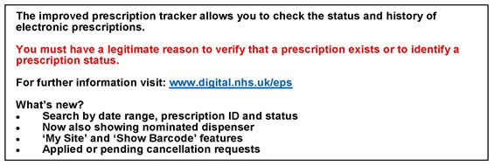

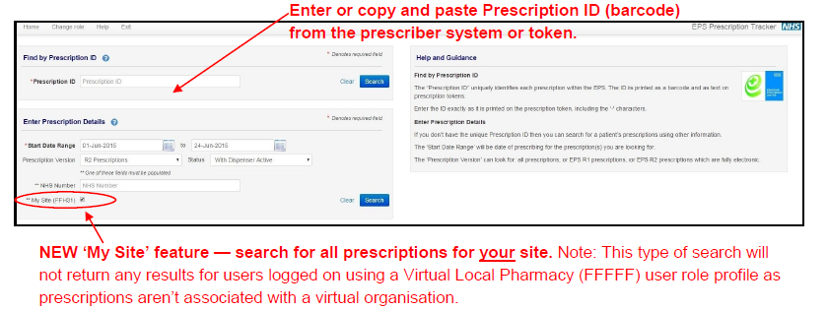

@EPSnhs

For more information on EPS visit: www.digital.nhs.uk/eps

**The EPS prescription tracker doesn’t make any clinical or sensitive information available about a patient's prescription.**





**Electronic Prescription Service (EPS) - Prescription Tracker**

**Factsheet for dispensers**

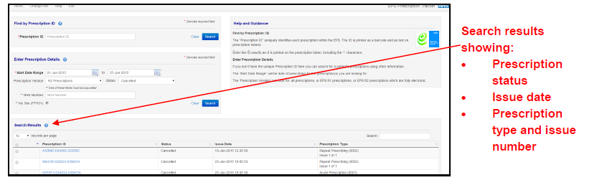



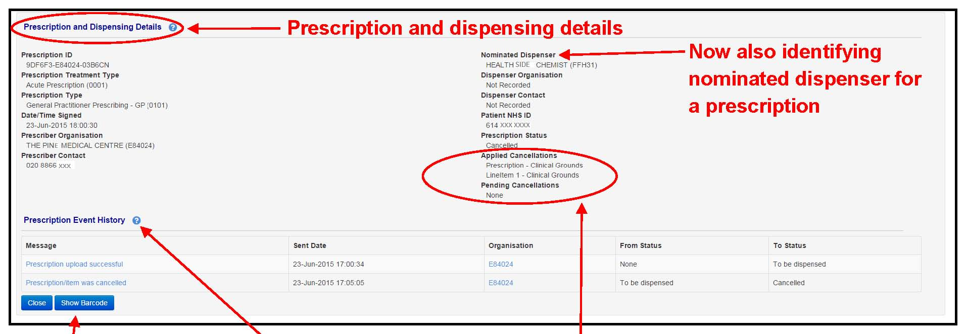

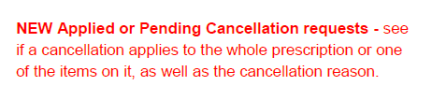

**@EPS**

**Benefits of the prescription tracker:**

