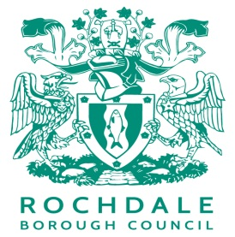 |  | Public Health  Service address:  3rd Floor Number One Riverside,  Smith Street, Rochdale,  OL16 1XU  Tel: (01706) 92 7062  Fax: 0844 332 0268  Email: invoices.PublicHealth@rochdale.gov.uk

PUBLIC HEALTH LOCALLY COMMISSIONED SERVICES (LCS) 2018/19
PAYMENT SCHEDULE AS OF 1ST APRIL 2018
PHARMACY

All payments for Locally Commissioned Services will continue to be processed by RBC via Public Health. A summary of the schedule and changes is below.

Frequency:
Monthly
- EHC
Invoice and validation document(s) to be forwarded by 7th of the month to Public Health.

- Chlamydia Screening & treatment**
Invoice and validation document(s) to be forwarded by 7th of the month to Public Health.

A full breakdown including tariff is on the reverse of this summary.
**

Public Health Locally Commissioned Services and Schedule 2018/19

Service 002** | Chlamydia Screening and Treatment
Claim/Validation | monthly submission to Public Health by 7th
Monthly Payment | via RBC finance
Activity
Service element | advice and explanation of the service and provision of the test kit | antibiotic treatment of positive clients | pregnancy testing
Tariff*** (£s) | 10.00 | £25.00 | £5.95
Reimbursement of antibiotic costs | Azithromycin 250mg tablets | Azithromycin (Zithromax) 250 capsules
Tariff*** (£s) | 10.36 | 10.09

Service 003** | Emergency Hormonal Contraception (EHC)
Claim/Validation | monthly submission to Public Health by 7th
Monthly Payment | via RBC finance
Activity | Consultation and advice  Consistent with protocol and PGD | pregnancy testing | Reimbursement of Levonorgestrel 1.5mg
Tariff*** (£s) | 25.00 | 5.95 | 5.20

