**Nicotine Replacement Therapy Voucher Scheme Update**

**Background**

There is evidence to suggest that COVID-19 is more debilitating in smokers and that people should be encouraged to stop smoking if possible. There is currently a #QuitforCovid campaign running nationally to encourage smoking cessation, therefore the access to Nicotine Replacement Therapy (NRT) will need to be made available to patients.

In view of the COVID-19 pandemic, the provision of NRT through the NRT voucher scheme have been reviewed and a new model have been agreed with the Local Pharmaceutical Committee. This new model aims to deliver a paperless and non-patient facing service, which is in line with the government’s social distancing measures and should help reduce footfall to local pharmacies.

**Old Model**

1. Smoking advisors conducts face to face clinic with the service user
2. Issues the service user with a paper voucher specifying their NRT recommendation
3. Service user presents this paper NRT voucher at a local pharmacy
4. Local pharmacy supply NRT products against this paper NRT Voucher.

**New Model**

1. Smoking advisors conducts telephone consultation with the service user
2. Smoking advisors generates a PharmOutcome referral
3. NRT referral is sent electronically to the PharmOutcomes referral screen of a local pharmacy
4. Local pharmacy supply NRT
5. Local pharmacy request delivery of NRT to the service user

**NB**: This model essentially replaces the “paper NRT voucher” with an electronic referral pathway and aims to deliver the NRT products directly to patients’ home.

**Processing a NRT referral via PharmOutcomes**

Referrals from smoking advisors will be received on the “Service” screen as seen below:

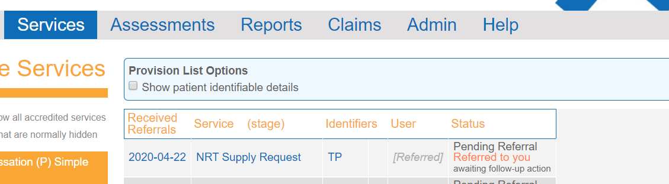

The referral will now need to be opened and processed; you will then be presented with the following screen:

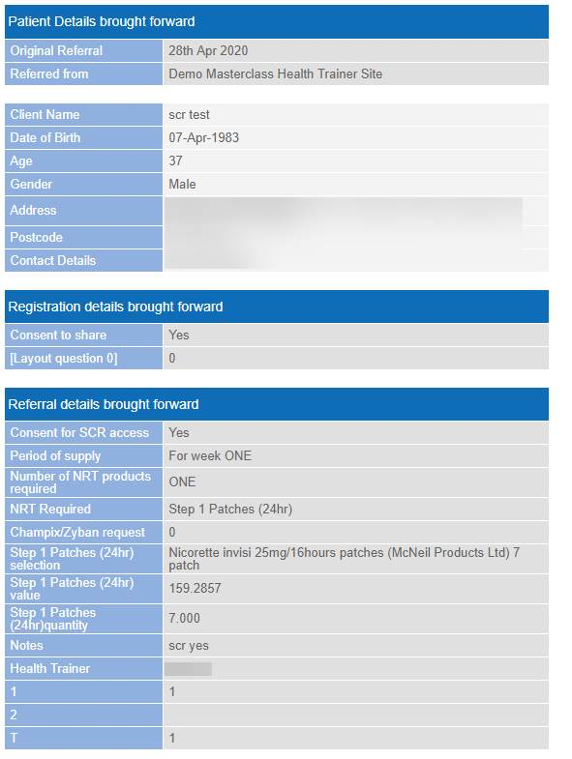

This referral form brings forward all the information captured by the smoking advisor and highlights any consent which has been obtained from the patients to view confidential information.

To process this referral, please select “Complete now” in the screen below:

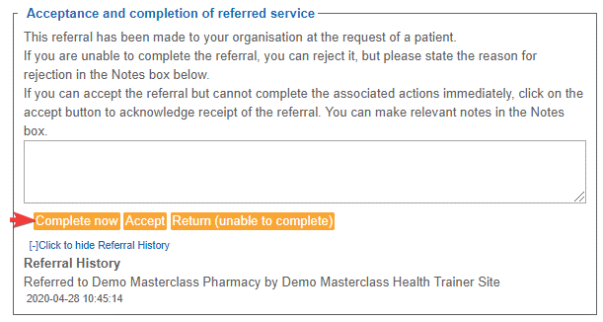

After “Complete now” have been selected, you be presented with the following screen:

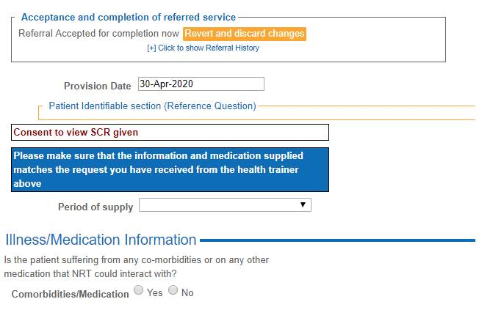

You will notice that “Consent to view SCR given” have been highlighted. This meant consent to access the service user’s summary care record (SCR) have been gained by the smoker advisor allowing you to access the service user’s SCR to answer the following question:

“Is the patient suffering from any co-morbidities or on any other medication that NRT could interact with?”

In the cases where “Consent to view SCR NOT given” is shown, other routes may have to be sought to ensure NRT supply is appropriate. e.g. Phone call to patient.

Once you are satisfied that the supply of NRT is appropriate, please select the period of supply; this should match with the period of supply brought forward on the referral form.

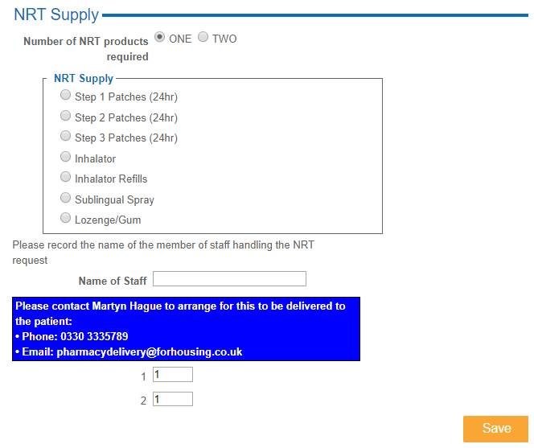

The NRT product to be supplied should then be selected, as per the NRT referral brought forward. Please note that the brand of the product could be amended according to stock availability in the pharmacy as long the NRT product type remains the same.

Once the NRT supply form have been completed, please contact Martyn Hague from ForHousing as per the telephone number highlighted: **0330 333 5789** to request delivery of the NRT to the patient. The delivery service will be carried out by volunteer drivers from Salford Community and Voluntary Service (CVS). The file below gives an overview of the Salford Volunteer Medicines Delivery Service; the volunteer drivers from Salford CVS will be following this SOP.



Please be assured that all volunteer drivers from Salford CVS have been DBS checked, fully insured and managed in accordance with volunteering England best practice guidelines.

If any issues are experienced when the electronically referral have been received, please do not hesitate to contact the smoking advisor who have made the initial referral.

**Payment**

Payment will be claimed automatically via PharmOutcomes. PharmOutcomes will process NRT claims on the 6th of the following month and at the end of each financial quarter as per below:

* For Q1 – 6th July
* For Q2 – 6th October
* For Q3 – 6th Jan
* For Q4 – 6th April

**NB**: Payment will include a £1 handing fee per item supplied as per the service specification. The prescription charge will not apply to this process.