9 Signatures
All parties agree to the content of the service level agreement and agree to deliver the service in line with the core requirements outlined above
This service is commissioned as an Enhanced Service under the Pharmaceutical Services (Advanced and Enhanced Services) (England) Directions 2013.

Signed for and on behalf of The Contractor (Owner) of the Community Pharmacy
(Contractor/Owner Name)

(Signature)

(Date)

(Pharmacy trading name, address and ODS code)

(If a Distance Selling Pharmacy, by signing the pharmacy contractor declares that there will be no face to face delivery of essential pharmaceutical services at or in the vicinity of the pharmacy premises)

Signed for and on behalf of NHS England and Improvement as part of the Greater Manchester Health and Social Care Partnership (The Commissioner)

(Signature) 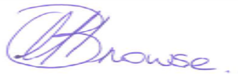 Director of Primary Care (Interim)

(Date) 1st November 2020

