**NHS GM Pharmacy Concerns, Concerns and Queries signpost**

To ensure you are approaching the correct organisation and department with relation to you queries and concerns, please see below appropriate signposting.

**Contractual concerns**

If you have a contractual concern relating to another pharmacy, then please compete the Pharmacy contractual incidents and concerns proforma and email to [gmhscp.gmtop@nhs.net](mailto:gmhscp.gmtop@nhs.net) you may also wish to the engage the support of CPGM to mediate with disputes between contractors.

**Patient Complaints**

To ensure that you or your patients concerns and complaints are dealt with appropriately and timely please note that disputes relating to patient nominations cannot be investigated until the patient has reported their complaint themselves or via an advocate, that cannot be an NHS Contractor as this would be deemed as conflict of interest. **Therefore, please direct patients to formally complain to either their locality (see locality document) or to the contact details above.**

* Email: [nhsgm.patientservices@nhs.net](mailto:nhsgm.patientservices@nhs.net)
* Phone: 0161 271 3980, 9am-4pm Monday-Friday (excluding Bank Holidays)
* Post: NHS Greater Manchester, 4th Floor, Piccadilly Place, Manchester, M1 3BN.

**Control Drugs Concerns**

For control drugs concerns please ensure that any Controlled Drug Incident or Concern: [www.cdreporting.co.uk](http://www.cdreporting.co.uk) For Controlled Drug Queries please email: [england.nwcdreporting@nhs.net](mailto:england.nwcdreporting@nhs.net)

**Concerns relating to NHS Prescription Services**  please see [Contact NHS Prescription Services | NHSBSA](https://www.nhsbsa.nhs.uk/contact-nhs-prescription-services) for further information.

**Pre-registration concerns or queries via the MYS portal should be emailed to, email** [mys@nhsbsa.nhs.uk](mailto:mys@nhsbsa.nhs.uk)

**Safeguarding concerns** should be reported to your local safeguarding lead. We recommend you downloading the NHS Englad safeguarding app to ensure you always have up to date contact information for any area. See Link for detaills [NHS England » NHS England Safeguarding app](https://www.england.nhs.uk/safeguarding/nhs-england-safeguarding-app/)

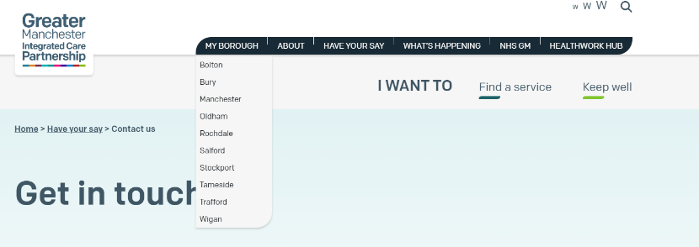**Medicines Management concerns** should be reported to your locality. Just click on”MY BOROUGH” for details [Contact us | Greater Manchester Integrated Care Partnership (gmintegratedcare.org.uk)](https://gmintegratedcare.org.uk/have-your-say/contact-us/)

**Specialised Services**

If you have a complaint about a specialised service commissioned by NHS England, please contact:

* Telephone: 0300 311 22 33
* Email: [england.contactus@nhs.net](mailto:england.contactus@nhs.net)
* Post: NHS England, PO Box 16738,Redditch,B97 9PT

**FOI Requests** please email [nhsgm.foi@nhs.net](mailto:nhsgm.foi@nhs.net)

Please write “Freedom of Information” in the subject line of any FOI request.

**Market Entry concerns and queries** [pcse.marketentry@nhs.net](mailto:pcse.marketentry@nhs.net)

For **more signposting information** please see [Contact us | Greater Manchester Integrated Care Partnership (gmintegratedcare.org.uk)](https://gmintegratedcare.org.uk/have-your-say/contact-us/)