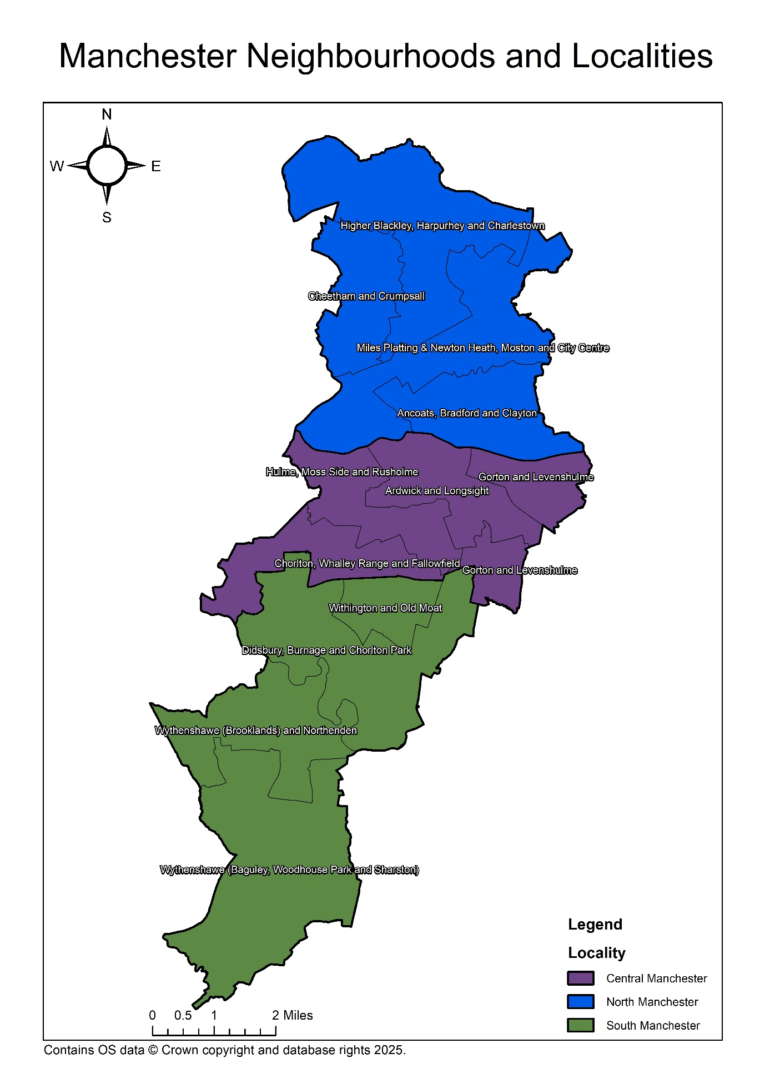
Manchester Health and Wellbeing Board PNA 2025-2028 Appendix 8: Maps 2025

Map 1: Map outlining the 12 neighbourhoods across the City of Manchester.

Map 2: Statutory map highlighting the geographical position of all pharmacies within Manchester Health and Wellbeing Board.
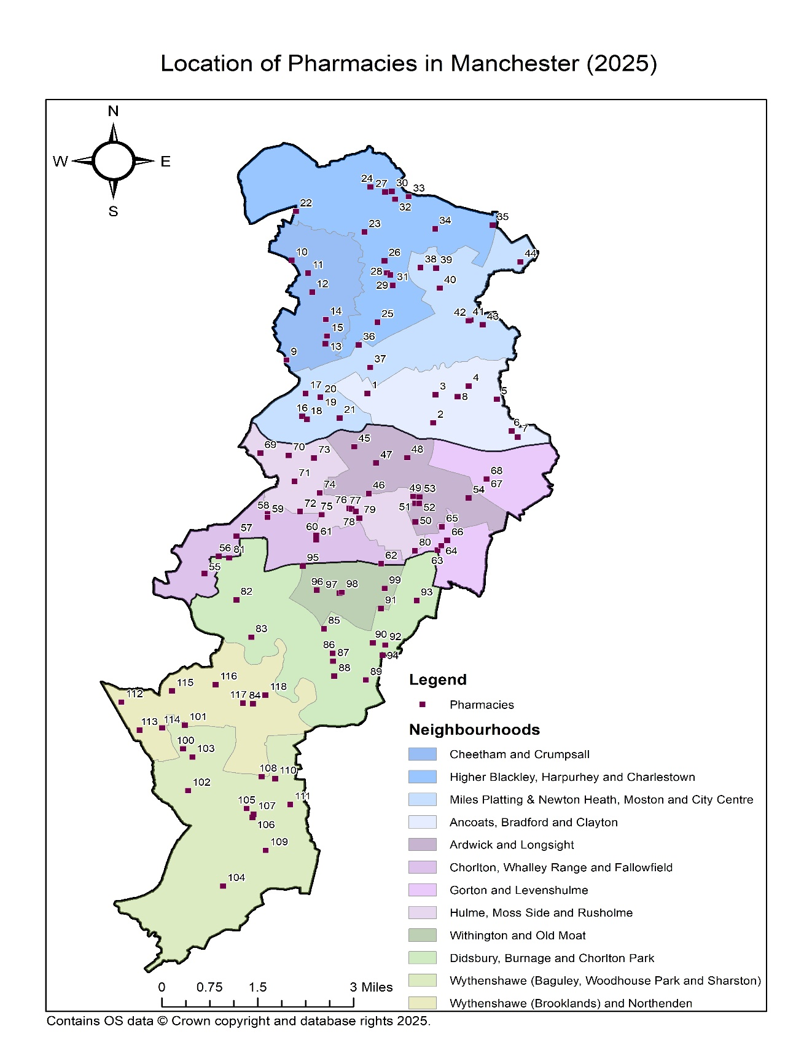
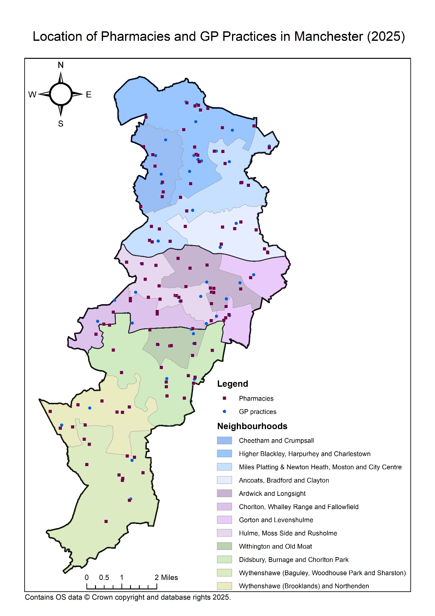
Map 3: Map highlighting the geographical position of all pharmacies and GP practices within Manchester Health and Wellbeing Board.
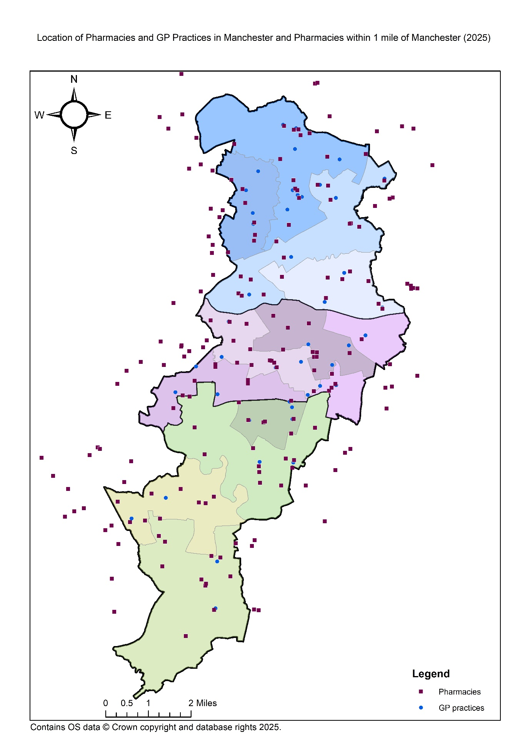
Map 4: Map highlighting the geographical position of all pharmacies, GP practices and pharmacies within a one-mile boundary of Manchester Health and Wellbeing Board.

