1 | Which Christmas song does the following line come from:  “Snow is fallin’, all around me, children playin’, havin’ fun.” (bonus point for the artist) | Shakin’ Stevens (Merry Christmas Everyone)
2 | True of false Mariah Carey tried to trademark the title ‘Queen of Christmas’ and lost. | True
3 | What is the shortest day of the year in the Northern Hemisphere called? | The Winter Solstice
4 | (Guess the Film by the Odd Clue)  Time travel, ghosts, and one massive underpaid intern problem. | The Christmas Carol
5 | What is the recommended minimum indoor temperature for keeping well in winter (as advised by UK health guidance)? | Around 18°C (especially for older adults)
6 | Which virus is often refered to as the Winter Vomiting Virus? | Norovirus
7 | What festive treat do the Cratchit family share for Christmas dinner in the Muppet Christmas Carol? | A very small goose
8 | Now is the Winter of our discontent is the opening line to which Shakespeare Play | Richard III
9 | True or false: The first artificial Christmas trees were made from goose feathers. | True (dyed green in 19th-century Germany)
10 | Finish the Christmas Lyric (But Wrongly) 1 point for the one the CPGM team like the best  It’s beginning to look a lot like…
11 | If Santa has 8 reindeer and 4 go on strike, how many legs are still pulling the sleigh? | 16 legs (4 reindeer x 4 legs each)
12 | In Venezuela, people travel to early-morning Christmas church services using what unusual mode of transport? | Roller skates
13 | Christmas Joke: Why did Santa go to the doctor? | Because of his bad elf
14 | Which Christmas song does this line come from?  “Oh, the weather outside is frightful, but the fire is so delightful.” | Let it snow.
15 | True or false: Christmas crackers were invented by a London sweet maker inspired by the crackle of a fire. | True (Tom Smith, 1847)
16 | Which country is known for having an annual Ice Hotel built entirely from snow and ice? | Sweden (Jukkasjärvi)
17 | Which film is this Santa from: 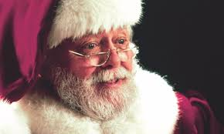 | Miracle on 34th Street
18 | Which Christmas movie was the first film ever screened in space? | Home Alone
19 | Which Christmas film is this?  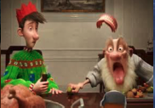 | Arthur Christmas
20 | Which month is typically the coldest in the UK? | January
21 | According to the story, how many sizes too small is the Grinch’s heart at the start? | Two sizes too small
22 | What is this?   | Stollen
23 | (Guess the Film by the Odd Clue)  “A divorced dad accidentally kills Santa and immediately takes his job without a DBS check.” | The Santa Clause
24 | What condition can cause fingers to turn white or blue when exposed to cold? | Raynaud’s phenomenon
25 | Which city is this at Christmas? 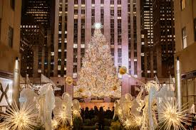 | New York

